Position details
Group: | Strategy, Planning and Climate Change
Branch: | Parks and City Greening
Team: | Open Space Planning and Green Infrastructure
Reports to: | Principal Open Space Planner
Position No: | 11086, 20191 C8841
Classification: | 6
Financial management | NIL
Direct reports: | NIL
Volunteers being supervised by this position: | NIL
Job Family: | Planning Design and Development – Urban Planning and Policy

Our Vision and the Way we Work
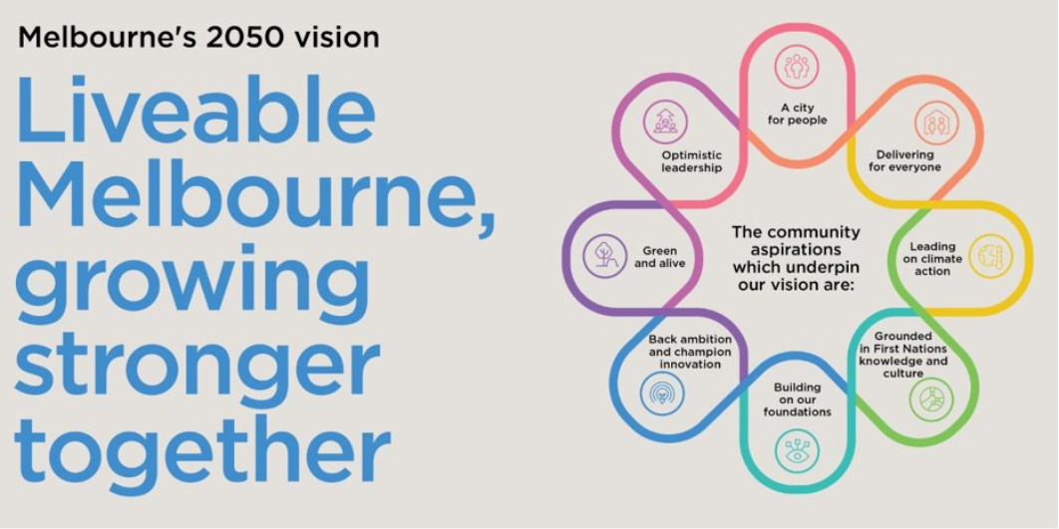

The way we work is underpinned by our Values:
- INTEGRITY is being honest and reliable in all dealings with others and conducting activities professionally and ethically.
- COURAGE means to step out of our own comfort zone and accept responsibility for the consequences of our own actions.
- ​​​​​ACCOUNTABILITY means to take personal responsibility for decisions and actions to achieve agreed outcomes.
- RESPECT means to value the contribution and individuality of others and contribute to healthy working relationships.
- EXCELLENCE means we aim to achieve the highest standard and best possible result in everything we do.

Team context
Parks and City Greening
The Parks and City Greening Branch is responsible for the strategic planning, management, and maintenance of Council’s parks, open space and street trees. The Parks and City Greening Branch adopts a holistic approach, combining strategic foresight and operational excellence to enhance, protect and extend the city’s network of parks and green infrastructure, which is central to the city’s livability, amenity and global brand.

The Parks and City Greening Branch will transform its approach and service to respond to the significant population growth of Melbourne, the changing demographics and needs of the population, and the climate and biodiversity crisis, to ensure the open space and green infrastructure network supports Melbourne’s resilience, and the health and wellbeing of its citizens and the city’s ecology.

Open Space Planning and Green Infrastructure
This team leads both the open space planning and green infrastructure portfolios for the organisation. It plans and delivers parks and city greening for the health and wellbeing of the community and the environment. It does this by:
- Improving and protecting our parks
- Increasing the number and diversity of our parks
- Increasing vertical and rooftop greening
- Advocating and negotiating positive outcomes relating to open space, green infrastructure and environmentally sustainable design.

Position Purpose
The purpose of the position is to provide professional guidance and support on open space, parks and gardens policy and planning matters in the delivery of open space planning services to Council. The Senior Open Space Planner is responsible for policy development, strategic planning, delivery and long term management of the City of Melbourne’s open space network.

The Senior Open Space Planner position requires demonstrated experience and a sound knowledge in project management, for medium-to-large, complex projects and a demonstrated ability in exercising technical leadership and appropriate judgement in the delivery of projects relating to parks, gardens and reserves (in particular).

The Senior Open Space Planner brings a high standard of critical and rigorous analysis of proposals and reports related to open space network outcomes and collaborates with and advises internal and external parties on CoM open space policies and issues.

The Senior Open Space Planner develops master plans, policies and strategies for the open space network within the City of Melbourne. They are responsible for the delivery of projects which deliver on strategic intent.

The Senior Open Space Planner assists the Open Space Planning and Green Infrastructure team and the Manager with the development, implementation and review of park management practices and proposes achievable contemporary solutions. In doing so, the Senior Open Space Planner is required to analyse issues, situations and problems and develop timely, innovative and effective responses.

The Senior Open Space Planner provides support to broader Council projects as determined by the Principal Open Space Planner and the Manager Open Space Planning and Green Infrastructure.

Key Accountabilities
- Open space planning, including: conservation and heritage planning and management; Crown land planning and management; service planning and management; statutory planning; relevant legislative and regulatory requirements.
- Undertake community engagement on projects in accordance with the City of Melbourne’s policies.
- Assess community requests as related to open space use and function.
- Coordinate interdisciplinary teams relating to open space projects.
- Manage high level and extensive stakeholder input into the development of policies, plans and projects.
- Educating and advocating for the implementation of open space policies and projects within the City of Melbourne on publicly managed land.
- Develop and maintain relationships with state government, adjoining local governments, industry and tertiary research institutions.
- Develop and submit funding bids.
- Manage internal and external working groups as required.
- Develop processes for parks, gardens and open space projects including preparation of project briefs; manage projects within budget and to agreed timelines; prepare reports and undertake evaluation.
- Participate in continuous improvement activities within the team and organisation.

Key Relationships
Internal | External
Parks and City Greening  City Design  City Projects  Recreation and Waterways  City Property  Aboriginal Melbourne  City Strategy  City Infrastructure  Planning and Building  Experience Melbourne  Community Development  Council advisory committees & groups | Relevant community & business groups  Traditional Owners  External advisory committees, networks and groups  Other government departments, agencies and local governments  Industry bodies  Consultants  Authorities  Neighbouring Land Managers
Key Selection Criteria
All CoM employees will demonstrate an ability to articulate and demonstrate benefits of positive culture and values.
In addition, the position will require: {no more than 8 selection criteria specific to this role}
- A tertiary qualification in Recreation, Landscape Architecture, Planning, Natural Resource Management, Horticulture, or equivalent
- Relevant professional experience and applied knowledge of open space planning
- Highly developed analytical and lateral thinking skills and demonstrated experience in solving complex problems relating to open space networks, Crown Land management, parks and gardens or environmental management
- Highly developed project management skills and demonstrated experience in managing projects within timelines and budgets
- Excellent stakeholder engagement and communication skills with an ability to represent Council in public forums and to negotiate win-win outcomes
- Ability to select, supervise and monitor the performance of consultants undertaking the preparation of reports and other projects

Desirable
- Proven ability to establish and maintain multidisciplinary networks across levels of government and professions to achieve open space planning strategic objectives
- Local government experience

Inherent Requirements
The reference to the Inherent Requirements for this position is DM 19273628.

Commitment to Child Safety
The City of Melbourne is a child-safe organisation with zero tolerance for child abuse. All children and young people have the right to be and feel safe. We embed child safety into daily practice and require all employees, volunteers and contractors to understand, prevent, detect and report any concerns relating to child safety.

